## health and safety

Enquiries to: Manager, Team Leaders, Safety Officer

Applies to: All children, parents, guardians, teachers and relievers, contractors and visitors.

Date developed: September 2017.

Date Reviewed: September2022

Next Review Date: September 2023

Location of file:

Last saved: 14/09/2022

Management consulted Yes/No Teachers consulted Yes/No

Parents consulted Yes/No

Approved by Jenni Mason Designation: Centre Manager Date: 14/09/22

**RATIONALE:**

Gracefield Early Childhood Centre is committed to providing a safe and healthy environment for all teachers/workers, enrolled children, contractors and visitors to our facilities.

**The Centre’s Duty of Care**

The Centre has a primary duty of care to ensure, so far as is reasonably practicable, the health and safety of workers (including teachers, casual teachers, contractors, children, whānau, and visitors).

The duty of care includes, but is not limited to, so far as is reasonably practicable:

* providing and maintaining a safe work environment including buildings and equipment
* providing and maintaining safe systems of work, including use of equipment and review of work practices
* providing adequate facilities for the welfare of workers at the Centre
* providing any information, training, instruction, or supervision to promote health and safety at the Centre.
* monitoring health of workers and conditions at the Centre to prevent injury or illness of workers and support teachers to return safely to work as soon as possible.

The Centre’s duty of care includes both the physical and psychological environment in which we operate. Specific practices put in place by the Centre to prevent or manage risks to Health and Safety are set out below.

**POLICY:**

**COVID 19**

**While the country is subject to government restrictions under any alert level we will comply with all requirements from the Ministry of Education (MoE) and/or the Ministry of Health (MoH).**

**This policy includes all Persons at the Centre, including workplace visitors and casual volunteers at workplaces.**

For further information please see the Covid 19 Policy.

**WORKER ENGAGEMENT AND PARTICIPATION DUTIES**

Workers include employees, contractors, subcontractors, labour hire workers, apprentices and trainees, and volunteer workers.

**Worker engagement**

A safe workplace is more easily achieved when everyone involved in the work communicates with each other to identify hazards and risks, talks about any health and safety concerns and works together to find solutions. The Centre will:

* engage with workers on health and safety matters that may directly affect them.
* include health and safety in all regular staff meetings to enable teachers to raise any issues; and
* the Centre Manager will be available to discuss health and safety matters as a priority.

**Worker responsibilities**

Workers need to take reasonable care for their own health and safety and that of others, including:

* actively contributing to hazard identification and management
* participating in Health and Safety training.
* adopting safe work practices and encouraging others to do so.
* report injuries promptly and accurately.
* participate in return-to-work programme, if applicable.

Workers need to comply with reasonable instructions from the Centre Manager and with policies and procedures.

Workers have the right to cease work if they believe that work would expose them or another person to a serious Health and Safety risk. The worker must inform the Centre Manager as soon as possible, and work to resolve the issue (guidance on rights and options is available from the WorkSafe NZ website).

**Other Persons at the Centre**

Other Persons at the Centre include workplace visitors and casual volunteers at workplaces.

Other Persons must take reasonable steps to keep themselves safe, not cause others harm, and comply with reasonable health and safety instructions. They can be held legally responsible if they cause someone harm and did not take reasonable care.

**Children at the Centre**

The Health and Safety of our children is our first priority. This is the responsibility of the Centre, Management, Workers, and Other Persons. We will work together to ensure safe behaviours by the children and a safe environment for them.

**Risk Management**

Health and Safety risk management is a shared responsibility at the Centre. Risks will be eliminated so far as is reasonably practicable. If a risk cannot be eliminated, it will be minimised so far as is reasonably practicable.

This policy identifies specific standing risks at the Centre and the measures in place to minimise them. See Annex One.

**PROCEDURE:**

**Risk Identification**

* All hazards likely to cause serious harm will be notified to management immediately.
* Every day a designated teacher will address any identified hazards in the outside play area before children access the area. The checking process will be confirmed by a daily checklist located by the health and safety notice board.
* At regular staff meetings all teachers will be given the opportunity to notify management of any hazards recently identified. It is the responsibility of each individual teachers to notify management of any hazard they are aware of.
* Three monthly inspections of all premises carried out by the Manager and documented in the Maintenance Register.
* Centre notice boards will be used to alert all teachers and visitors to any temporary hazards identified on a day-to-day basis.
* A list of identified hazards will be sighted and signed by all teachers, casual teachers, volunteers, visitors and contractors. Parents will sight the list on enrolling their child. The list of hazards will be displayed prominently in each centre and updated as required.

**Risk Monitoring and Mitigation**

* All accidents (teachers and children) will be documented in the accident register and this will be regularly reviewed at staff meetings to identify any patterns and/or necessary actions to be taken. Notifiable events will be reported to WorkSafe (see below)
* Any significant health and safety issues and the steps taken to eliminate, isolate or minimise the risk will be documented in the teachers meeting minutes and the Monthly Committee Reports.
* The Centre Manager will take immediate action to address identified risks and resolve them as soon as is practical.
* Risks and mitigations will be reported to the Management Committee.
* Working bees are arranged throughout the year to maintain a safe physical environment, for example, replacement of sand and bark chips, cleaning and general maintenance.

**Ensuring the Health and Safety of Workers**

**Teachers Training**

* Bi-yearly training for fire wardens, cooks and others, including the use of the extinguishers, will be provided.
* All regular teachers are required to maintain current First aid Qualifications with the financial cost met by the Centre.
* Emergency evacuation procedures are practiced by all teachers, once a month. All drills to be documented.
* Training will be arranged by the manager to inform teachers of any preventative medications that are to be administered to the children, for example, Epi pens and insulin.

**Teachers Health**

* Regular teachers will be offered free flu vaccinations annually.
* All teachers will be informed of the risk to their health of contracting infectious diseases including chickenpox, rubella, tetanus, polio and hepatitis B. They will be encouraged to have their immunisation status checked.
* Teachers with infectious diseases are expected to stay at home. Further information is included in Annex One.
* Disposable gloves will be readily available to teachers at all times. These will be worn when an exchange of bodily fluids could put the health of the child or teachers at risk. e.g. changing a soiled nappy, treating a child when blood or vomit are present.

**Safe return to work** Any employee who is on ACC leave will be supported in returning to work. Management, after considering any budget implications, will if possible, offer light duties and work with ACC to facilitate a return to work as soon as possible.

* Teachers will be supported to return to work after an injury or illness with a return-to-work plan. The plan will be developed in consultation with the Governance Group/ECE Centre, the ill or injured worker, the
* Health and Safety Representative and other relevant parties such as the union representative, the treatment provider, ACC, and the medical insurer.
* The plan will include clear objectives, a list of actions to be taken to enable return to work, and the person responsible for each action. It may include:
  + suitable duties being offered including modified or alternative duties/
  + hours of work and work breaks (frequency and duration)
  + support, aids or modifications to the workplace
  + special needs or conditions and what will be done to help (e.g. assistance with transport)
  + time frames
  + monitoring and reviewing progress so that problems can be identified and managed early.

**Notifiable Events; Managers responsibility**

After becoming aware that a notifiable event has occurred arising from work, the Board/ECE must immediately ensure that Worksafe NZ is notified by the fastest possible in the circumstances means. Notification may be given by telephone (0800 030 040) or in writing (including by email, or other electronic means).

A person giving notice by telephone must give details of the incident requested by WorkSafe, and if required by WorkSafe, give a written notice of the incident within 48 hours of the request. Notices given in writing must be in a form, or contain the details, approved by WorkSafe.

**Who else should be notified when a notifiable event occurs?**

**EMERGENCY SERVICES: 111**

**WORKSAFE: 0800 030 040**

**MINISTRY OF EDUCATION (04) 463 8699**

1. When a notifiable event occurs the priority is to assist the injured or ill person.

2. This may involve calling in ambulance services, a doctor, and/or the Police.

3. After notifying WorkSafe, management should notify the Ministry of Education. It may also be advisable to contact the service’s insurer and to seek legal advice.

**What is management’s duty to preserve the site where a notifiable event has occurred?**

Management must take all reasonable steps to ensure that the site where the event occurred is not disturbed until authorised by an inspector. However, this does not prevent any action:

» to assist an injured person » to remove a deceased person.

» That is essential to make the site safe or to minimise the risk of a further notifiable event » that is done by, or under the direction of, a (Police) constable acting in execution of his or her duties.

» for which an inspector or the regulator (WorkSafe) has given permission for the purposes of this section, a site includes any plant, substance, structure or thing associated with the notifiable event.

**What is management’s duty to notify a notifiable event?**

Management must keep a record of each notifiable event for at least 5 years from the date on which notice of the event is given to Worksafe. The record must contain the particulars described by regulations (if any).

The Centre will ensure WorkSafe is told when a notifiable event occurs. A notifiable event is where serious harm occurs requiring treatment other than first aid or a near miss (refer Annex 2, which contains guidance from WorkSafe).

Should a notifiable event occur, Management will ensure the site of the incident is undisturbed, except to help an injured person or make the site safe until the police or WorkSafe direct otherwise.

The Centre will notify WorkSafe by the fastest means possible given the circumstances. WorkSafe can be notified as follows:

* By telephone 0800 030 040
* Email [healthsafety.notification@worksafe.govt.nz](mailto:healthsafety.notification@worksafe.govt.nz)
* Forms and alternative ways to notify can be found through the website [www.worksafe.govt.nz](http://www.worksafe.govt.nz)
* Notification forms can be accessed on the link below:

<http://www.business.govt.nz/worksafe/notifications-forms/accident-serious-harm>

* Templates of forms to support the implementation of Health and Safety procedures can be accessed on the link below:

[http://www.education.govt.nz/ministry-of-education/specific-initiatives/health-and- safety/implementing-the-health-and-safety-at-work-act-a-guide-for-early-learning-services/](http://www.education.govt.nz/ministry-of-education/specific-initiatives/health-and-%20%20%20%20safety/implementing-the-health-and-safety-at-work-act-a-guide-for-early-learning-services/)

**Annex One – Standing Risk Identification and Management**

**Infectious diseases**

* All teachers will be informed when infectious diseases are present in centre.
* If a teachers or child has a serious infectious condition it is expected they will stay at home until the condition is under control and no longer infectious.
  + Any teachers or child suffering from an infectious disease (as per second schedule - Infectious and Notifiable Diseases), is excluded from attending the centre.
  + Any teachers or child suffering from any other disease may be excluded at the discretion of the Centre Manager. This exclusion will be based on the guidelines provided in "Recommendations for inclusion/exclusion of children from early childhood centres from Regional Public Health. Refer also to the child health policy.
  + Length of time of exclusion will be based on recommendations from Public Health, or other appropriate professional health advice.
* In the event of the notification of an infectious illness that is dangerous to an unborn child, pregnant teachers may choose to remain at home until the risk of infection has passed.

**Stress**

Teachers are encouraged to talk to the Centre Manager about any problems which are causing stress. If discussions do not provide any clear outcome, then counselling and/ or courses may be offered as a solution. External advice from an Employment Assistance Programme (EAP) may also be sought.

**Repetitive Strain Injury / Gradual Process Injury**

Risks to well-being arising from ergonomic issues or eye strain should be reported to the Centre Manager as soon as possible. This includes any equipment or tasks that may be causing problems or leading to Repetitive Strain or Gradual Process Injuries (RSI, GPI, formerly known as Occupational Overuse Syndrome (OOS)). The Centre Manager will review the task or equipment and follow up with a recommended change in procedure, equipment or appropriate suggested action. If the problem continues, then outside help will be sought.

**Sun Care and Protection Policy**

Risks to workers and children from exposure to sun, including sunburn and heat stroke will be managed by:

* Regular application of sunscreen on children and workers
* Wearing on sun hats
* Provision of shade in outdoor areas
* Provision of drinking water

For further details see the Sun Protection Policy

**Emergency Plan and Procedures**

The Centre will maintain an up to date set of emergency procedures including evacuation procedures and response to civil emergencies. Teachers will receive appropriate and regular training on emergency procedures.

Refer Emergency Procedures policy for further details.

**Animal Welfare Policy**

* Any animal (insect or fish) confined on the premises will be housed in sanitary conditions and cared for with every consideration given to the animal's and children's welfare.
* All visiting animals will always be fully under the control of an adult. Each child will be in control of whether they have contact with the animal or not and at no time are the children or animal to be unduly stressed by the introduction of an animal to our environs.
* If a stray animal comes on to our property or is met during an outing the children's welfare will be secured followed by actions to ensure the welfare of the animal. SPCA, or owners will be notified. A stray animal will be confined in a separate space from the children.
* The children will be instructed to treat animals with care and respect at all times.
* Hand washing is compulsory after contact with an animal.

A**nnex Two – What is a Notifiable Event**

This Annex contains excerpts from WorkSafe NZ’s Introduction to the Health and Safety at Work Act 2015. It provides initial guidance on what constitutes a notifiable event. If in doubt, an event should be reported.

*Notifiable Incident.* A notifiable incident is an unplanned or uncontrolled incident in relation to a workplace that exposes the health and safety of workers or others to a serious risk arising from immediate or imminent exposure to the following:

* a substance escaping, spilling, or leaking.
* an implosion, explosion or fire.
* gas, steam or pressurised substance escaping.
* electric shock.
* the fall or release from height of any plant, substance or object.
* the collapse or partial collapse of a structure.
* any other incident declared in section 24 of the HSWA or in regulation to be a notifiable incident (eg specified incidents in the Health and Safety at Work (Petroleum Exploration and Extraction) Regulations 2016).

**Notifiable Injury or Illness**

A notifiable injury or illness is work related and requires immediate attention beyond basic first aid.

This flow diagram was developed by WorkSafe NZ to help assess whether an injury or illness is notifiable.

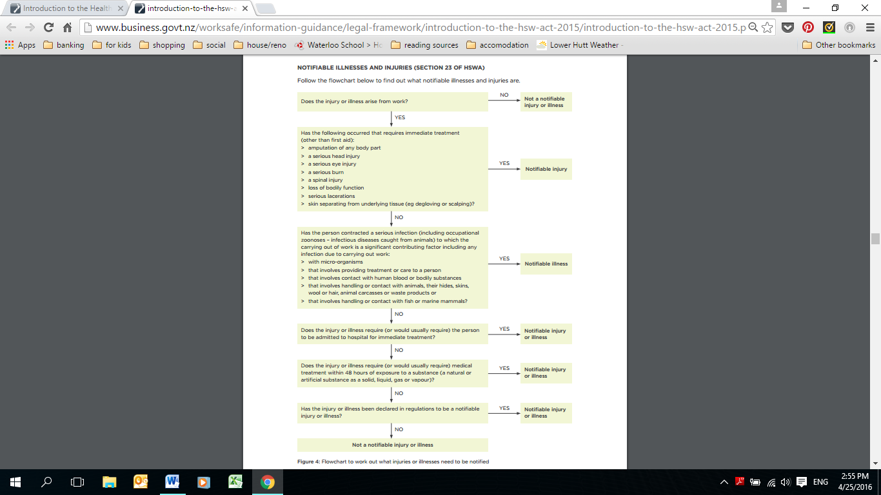

***References; Ministry*** of Education, Appendix A. Key Public Health requirements at Alert level 2 and Level 3.Health and Safety at Work Act 2015, Worksafe NZ (Introduction to the Health and Safety at Work Act 2015(April 2016), 2008 Ministry of Education 2008 Regulations, Licensing Criteria